Logbook

-By kai langley-

Week 4 – 8 hours outside of class

**(Wednesday 4pm – 6pm) - Team meetings**

Description: In the team meeting we talked about each group member's roles and what section they are doing. We Also set up GitHub as our repository access and project management tool, also making sure everyone had access to it.

**(Thursday 12 –2) - watch a video on java for beginners**

<https://www.youtube.com/watch?v=j9VNCI9Xo80>

[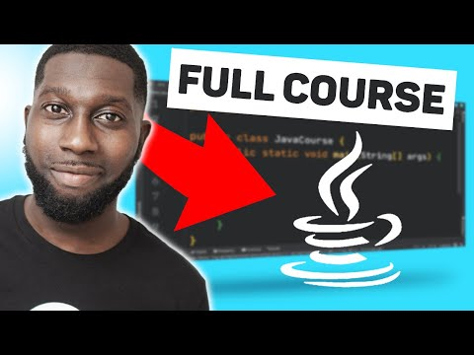](https://www.youtube.com/watch?v=j9VNCI9Xo80)

Thursday 2 to 3 - watch a video on git and git hub to get more of an understanding of how they work and how to use them

<https://www.youtube.com/watch?v=i76ts_0UryI>

[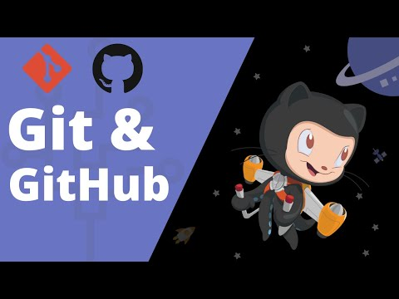](https://www.youtube.com/watch?v=i76ts_0UryI)

**(Friday 10pm to 12pm ) - Researched Multiplayer Mechanics**

Concepts and Mechanics of multiplayer games- <https://www.slavnastudio.com/blog/concepts-and-mechanics-of-multiplayer-games/>

The art of multiplayer mechanics-<https://www.numberanalytics.com/blog/multiplayer-game-mechanics>

Game mechanics- <https://canbayar91.medium.com/game-mechanics-1-multiplayer-network-synchronization-46cbe21be16a>

**(Friday 1 pm – 2pm) - 10 User Stories**

Description: I created 10 user stories for section 4 on multiplayer mechanics

1. I want to compete against players in real time so the game feels more interactive and competitive
2. If my game connection fails, i want to be able to rejoin the match if I briefly disconnect so I don't lose the game
3. I want to be able to create a private room for me and my friends
4. As a player, I want a quick matchmaking option so I can find an opponent without long waits.
5. I want me and my opponent to receive the same questions at the same time so the match is fair.
6. As a player, I want to see my score and my opponent’s score during the game so I can track progress.
7. I want the game to wait until both players have finished (or the timer runs out) before moving to the next question so the match stays in sync.
8. As a player, I want to see when my opponent has answered so I feel more engaged.
9. As a player, I want to see a clear win/lose/draw summary at the end of the match so the outcome is obvious.
10. I want the game to handle if my opponent quits mid-match so I don’t waste time and can either win by default or get a rematch option.